ASL Pipeline

# Preprocessing

For T1 Image:

(*T1_pre.sh & FAST.sh*)

1. Reorient Image (optional)
   * *fslreorient2std <input> <output>*
2. Skullstripping/Brain Extraction
   * *3DSkullStrip –input <input> -prefix <output>*
   * *bet <input> <output>*
3. Bias Field Correction
   * *bfc -i <input> -o <output>*
4. Segment Image to CSF/GM/WM
   * *fast -N -p -o <output_prefix> <input>*
5. Register probability map into ASL space
6. Register a single ASL image to T1 space to get the ASL->T1 transformation matrix

* *flirt -in <ASL_label001> -ref <T1_bfc> -o <output> -omat <ASL->T1_mat>*

1. Inverse the ASL->T1 transformation matrix to T1->ASL transformation matrix

* *convert_xfm -omat <T1->ASL_mat> -inverse <ASL->T1_mat>*

1. Register probability map

* *flirt -in <prob_map> -ref <ASL_label001> -applyxfm -init <T1->ASL_mat> -out <output>*

For ASL image:

(*ASL_pre.sh*)

1. Splitting 4D ASL into 3D Label Image and Control Image (only if acquired ASL is in 4D)
   * *fslsplit <ASL_4D_input> <ASL_3D_output> -t*
2. Motion Correction
   * *mcflirt -in <input> -o <output>*
3. Skullstripping/Brain Extraction
   * *bet <input> <output>*

# CBF Quantification:

(*CBF_quant.m*)

1. Calculate ASL Difference Image

* *ASL_diff = abs(control - label)*

1. Partial Volume Effect Correction

* *[imFil, imMap, errRes] = pveAsllani(GM_prob, WM_prob, [], ASL_diff, opt)*
* *perf_global = imFil*
* *perf_WM = imMap(1)*
* *perf_GM = imMap(3)*

1. Quantification of CBF GM & WM
   * One Compartment Model

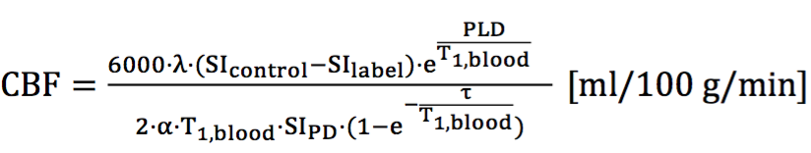

* Two Compartment Model

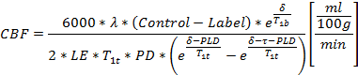

* Assumed parameters
  + λ = 0.9
  + T1,b = 1650 ms
  + α = 0.85 * 0.83
  + δGM = 1400 ms
  + δWM = 1600 ms
  + T1GM = 1332 ms
  + T1WM = 850 ms

1. Quantification of CBF Global

* *CBF_Global = CBF_GM * GM_prob + CBF_WM * WM_prob*

1. Select multiple middle slices of axial plane for CBF value
2. Register CBF to T1 space
3. Calculate territory CBF